Emmanuel Catholic College
Science Department
Year 9 Light and Sound Section Test 3 (5%) Mark: /50

Part A: Multiple Choices [10 marks] Full Name: ………………………………….

- Which statement applies to all waves?

  - Can move through a vacuum
  - Carry energy
  - Involve electric and magnetic fields
  - Travel faster in solids.

- Convex mirrors will “……” light rays.

  - converge
  - refract
  - transmit
  - diverge

- An object that produces light is:

  - opaque.
  - transparent.
  - translucent.
  - luminous.

- Compared to visible light, ultraviolet radiation has:

  - lower frequency and higher energy.
  - higher frequency and lower energy.
  - higher frequency and higher energy.
  - lower frequency and lower energy.

- Which material can be classified as translucent?

  - Red cardboard.
  - Window glass.
  - Frosted glass.
  - Carpet.

- The speed of light in air is:

  - 300 000 000 m/sec.
  - 300 000 m/sec.
  - 340 m/sec.
  - 300 km/sec.

- Sound travels fastest through a:

  - Gas.
  - Liquid.
  - Solid.
  - Vacuum.

- A decibel is a measure of:

  - Amplitude
  - Loudness
  - Frequency
  - Pitch

- What is meant by the frequency of a vibrating object?

  - The number of vibrations it makes.
  - How fast it vibrates.
  - The number of vibrations it makes in a second.
  - How much it moves from side to side.

- Sound travels in:

  - Straight lines
  - Compressions and rarefactions
  - Wavy lines
  - Crests and troughs

Part B: Short Questions [40 marks]

- a) In your own words, explain the difference between a compression and a rarefaction.
[2]
…..……………………………………………………………………………………………………………..

…..……………………………………………………………………………………………………………..

…..……………………………………………………………………………………………………………..

…..……………………………………………………………………………………………………………..

…..……………………………………………………………………………………………………………..

b) For the medium represented in A, neatly re-draw the particles in B to show two compressions and a rarefaction passing through the medium.
[2]

A

‘
B

c) Why is it not possible for sound to travel through outer space?
[2]
……………………………………………………………………………………………………………..

……………………………………………………………………………………………………………..

……………………………………………………………………………………………………………..

……………………………………………………………………………………………………………..

……………………………………………………………………………………………………………..

- a) Label the following illustration of the human ear.
[3.5]
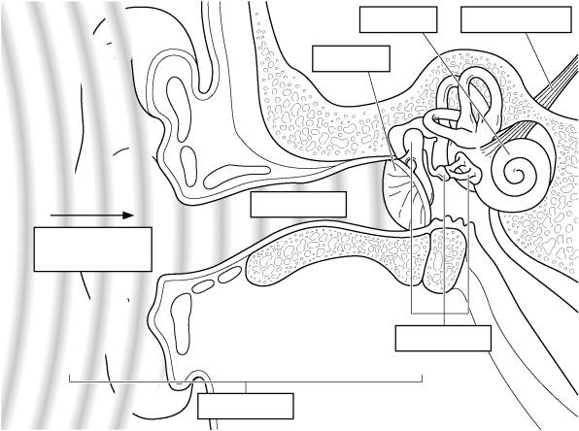

- The middle ear is made up of 3 individual bones. What are they named?
[1.5]
……………………………………………………………………………………………………………..

- a) Label the following illustration of the human eye.
[3]
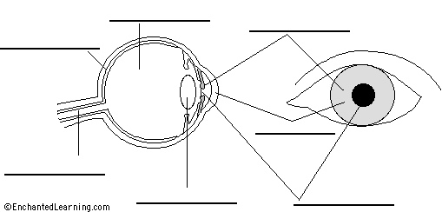

b) How does the eye focus light?
[2]
……………………………………………………………………………………………………………..

……………………………………………………………………………………………………………..

……………………………………………………………………………………………………………..

c) In terms of focusing light, why might a person need glasses?
[2]
……………………………………………………………………………………………………………..

……………………………………………………………………………………………………………..

……………………………………………………………………………………………………………..

- a) Label the following diagram of a wave.
[2]

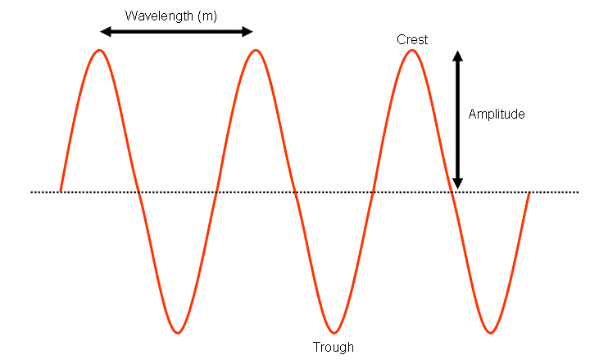

b) Complete the diagram of the electromagnetic spectrum by naming the remaining bands.
[2]
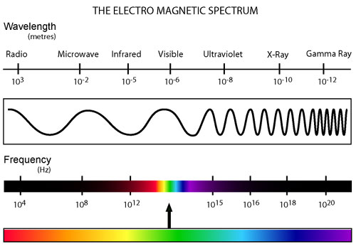

- How do the features of a wave change as you move from left to right along the EM spectrum? (Comment on frequency, wavelength and energy). Describe using radio waves and x-rays as examples.
[3]
……………………………………………………………………………………………………………..

……………………………………………………………………………………………………………..

……………………………………………………………………………………………………………..

……………………………………………………………………………………………………………..

- Of the visible light spectrum, which colour of light has the lowest frequency?
[1]
……………………………………………………………………………………………………………..

- Of the visible light spectrum, which colour of light has the highest energy?
[1]
……………………………………………………………………………………………………………..

- Show what happens to the path of light in the following scenarios.

[1]
Reflective surface
Backing

This is a ………………. mirror. [1]

It will ………………. light rays. [1]

Reflective surface
Backing
[1]

This is a ………………. mirror. [1]

It will ………………. light rays. [1]

Air
Water
Air
[4]
What is this phenomenon called?
[1]
…………………………………….

Why does light behave in this way?
[2]
……………………………………………………………………………………………………………..

……………………………………………………………………………………………………………..

……………………………………………………………………………………………………………..
END OF TEST

